**電通二乙微處理器實驗 實驗結報**

|  |  |  |  |
| --- | --- | --- | --- |
| **實驗名稱** | Lab02-跑馬燈 | | |
| **組別** |  | **組員** | **林智偉** |

1. **實驗目的**

**利用Ardino 7697 的接腳接到LED，做出題目所規定跑馬燈**

1. **實驗步驟**

**實驗一 :**

**1.LED向左及向右執行花色展示**

**實驗二 :**

**1.LED向左及向右執行花色展示**

**2. 執行自定花色展示:所有LED亮滅兩次 > 左移八次 > 所有LED亮滅兩次 > 右移八次**

**實驗三 :**

**1. Arduino接上一個開關**

**2. 開關 OFF > LED 向左及向右執行花色展示**

**3. 開關 ON > 執行自定花色展示**

1. **程式碼**

**實驗一**

**const byte startPin = 7;**

**const byte endPin = 14;**

**byte i;**

**byte n;**

**void setup()**

**{**

**for (byte i = startPin; i<= endPin; i++)**

**{**

**pinMode(i, OUTPUT);**

**}**

**}**

**void loop()**

**{**

**for (i=startPin;i<=endPin;i++)**

**digitalWrite(i, LOW);**

**for (i=startPin;i<=endPin;i++)**

**digitalWrite(i, LOW);**

**for (i=endPin;i>=startPin;i--)**

**{**

**digitalWrite(i, HIGH);**

**delay(100);**

**digitalWrite(i, LOW );**

**delay(100);**

**}**

**for (i=startPin;i<=endPin;i++)**

**{**

**digitalWrite(i, HIGH);**

**delay(100);**

**digitalWrite(i, LOW );**

**delay(100);**

**}**

**}**

**實驗二**

**const byte startPin = 7;**

**const byte endPin = 14;**

**byte i;**

**byte n;**

**void setup()**

**{**

**for (byte i = startPin; i<= endPin; i++)**

**{**

**pinMode(i, OUTPUT);**

**}**

**}**

**void loop()**

**{**

**for (i=startPin;i<=endPin;i++)**

**digitalWrite(i, LOW);**

**digitalWrite(7, HIGH);**

**digitalWrite(8, HIGH);**

**digitalWrite(9, HIGH);**

**digitalWrite(10, HIGH);**

**digitalWrite(11, HIGH);**

**digitalWrite(12, HIGH);**

**digitalWrite(13, HIGH);**

**digitalWrite(14, HIGH);**

**delay(100);**

**digitalWrite(14, LOW);**

**digitalWrite(13, LOW);**

**digitalWrite(12, LOW);**

**digitalWrite(11, LOW);**

**digitalWrite(10, LOW);**

**digitalWrite(9, LOW);**

**digitalWrite(8, LOW);**

**digitalWrite(7, LOW);**

**delay(100);**

**digitalWrite(7, HIGH);**

**digitalWrite(8, HIGH);**

**digitalWrite(9, HIGH);**

**digitalWrite(10, HIGH);**

**digitalWrite(11, HIGH);**

**digitalWrite(12, HIGH);**

**digitalWrite(13, HIGH);**

**digitalWrite(14, HIGH);**

**delay(100);**

**digitalWrite(14, LOW);**

**digitalWrite(13, LOW);**

**digitalWrite(12, LOW);**

**digitalWrite(11, LOW);**

**digitalWrite(10, LOW);**

**digitalWrite(9, LOW);**

**digitalWrite(8, LOW);**

**digitalWrite(7, LOW);**

**delay(100);**

**for (i=startPin;i<=endPin;i++)**

**digitalWrite(i, LOW);**

**for (i=endPin;i>=startPin;i--)**

**{**

**digitalWrite(i, HIGH);**

**delay(100);**

**digitalWrite(i, LOW );**

**delay(100);**

**}**

**digitalWrite(7, HIGH);**

**digitalWrite(8, HIGH);**

**digitalWrite(9, HIGH);**

**digitalWrite(10, HIGH);**

**digitalWrite(11, HIGH);**

**digitalWrite(12, HIGH);**

**digitalWrite(13, HIGH);**

**digitalWrite(14, HIGH);**

**delay(100);**

**digitalWrite(14, LOW);**

**digitalWrite(13, LOW);**

**digitalWrite(12, LOW);**

**digitalWrite(11, LOW);**

**digitalWrite(10, LOW);**

**digitalWrite(9, LOW);**

**digitalWrite(8, LOW);**

**digitalWrite(7, LOW);**

**delay(100);**

**digitalWrite(7, HIGH);**

**digitalWrite(8, HIGH);**

**digitalWrite(9, HIGH);**

**digitalWrite(10, HIGH);**

**digitalWrite(11, HIGH);**

**digitalWrite(12, HIGH);**

**digitalWrite(13, HIGH);**

**digitalWrite(14, HIGH);**

**delay(100);**

**digitalWrite(14, LOW);**

**digitalWrite(13, LOW);**

**digitalWrite(12, LOW);**

**digitalWrite(11, LOW);**

**digitalWrite(10, LOW);**

**digitalWrite(9, LOW);**

**digitalWrite(8, LOW);**

**digitalWrite(7, LOW);**

**delay(100);**

**for (i=startPin;i<=endPin;i++)**

**{**

**digitalWrite(i, HIGH);**

**delay(100);**

**digitalWrite(i, LOW );**

**delay(100);**

**}**

**}**

**實驗三**

**const byte leds[]={7,8,9,10,11,12,13,14};**

**const byte NUM=sizeof(leds);**

**int i;**

**int count;**

**int t;**

**void setup()**

**{**

**for(int i=0;i<NUM;i++)**

**{**

**pinMode(leds[i],OUTPUT);**

**}**

**pinMode(6,INPUT);**

**}**

**void loop()**

**{**

**t = digitalRead(6);**

**if( t== HIGH)**

**{**

**for(i=0;i<NUM;i++)**

**{**

**digitalWrite(leds[i],HIGH);**

**delay(100);**

**digitalWrite(leds[i],LOW);**

**}**

**for(i=NUM-1;i>=0;i--)**

**{**

**digitalWrite(leds[i],HIGH);**

**delay(100);**

**digitalWrite(leds[i],LOW);**

**}**

**}**

**else**

**{**

**for(i=0;i<2;i++)**

**{**

**digitalWrite(7,HIGH);**

**digitalWrite(8,HIGH);**

**digitalWrite(9,HIGH);**

**digitalWrite(10,HIGH);**

**digitalWrite(11,HIGH);**

**digitalWrite(12,HIGH);**

**digitalWrite(13,HIGH);**

**digitalWrite(14,HIGH);**

**delay(400);**

**digitalWrite(7,LOW);**

**digitalWrite(8,LOW);**

**digitalWrite(9,LOW);**

**digitalWrite(10,LOW);**

**digitalWrite(11,LOW);**

**digitalWrite(12,LOW);**

**digitalWrite(13,LOW);**

**digitalWrite(14,LOW);**

**delay(400);**

**}**

**}**

**}**

1. **實驗結果及分析**

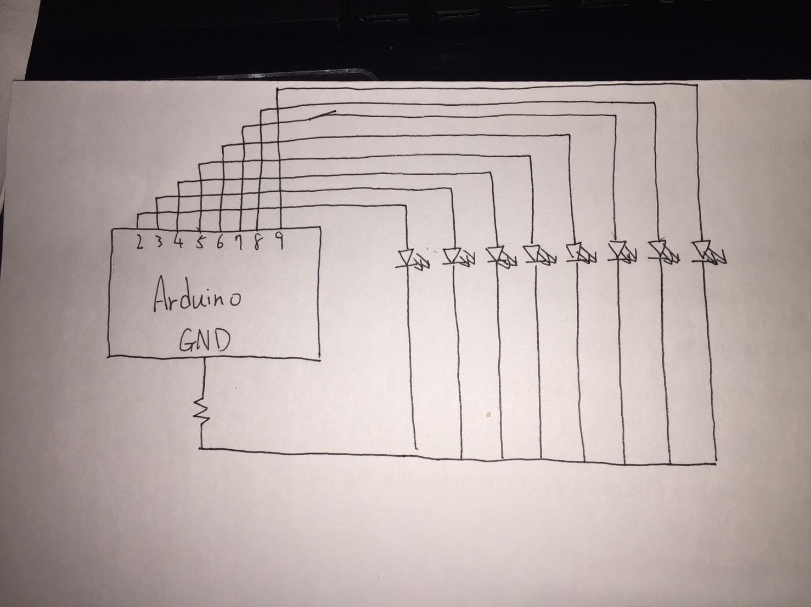

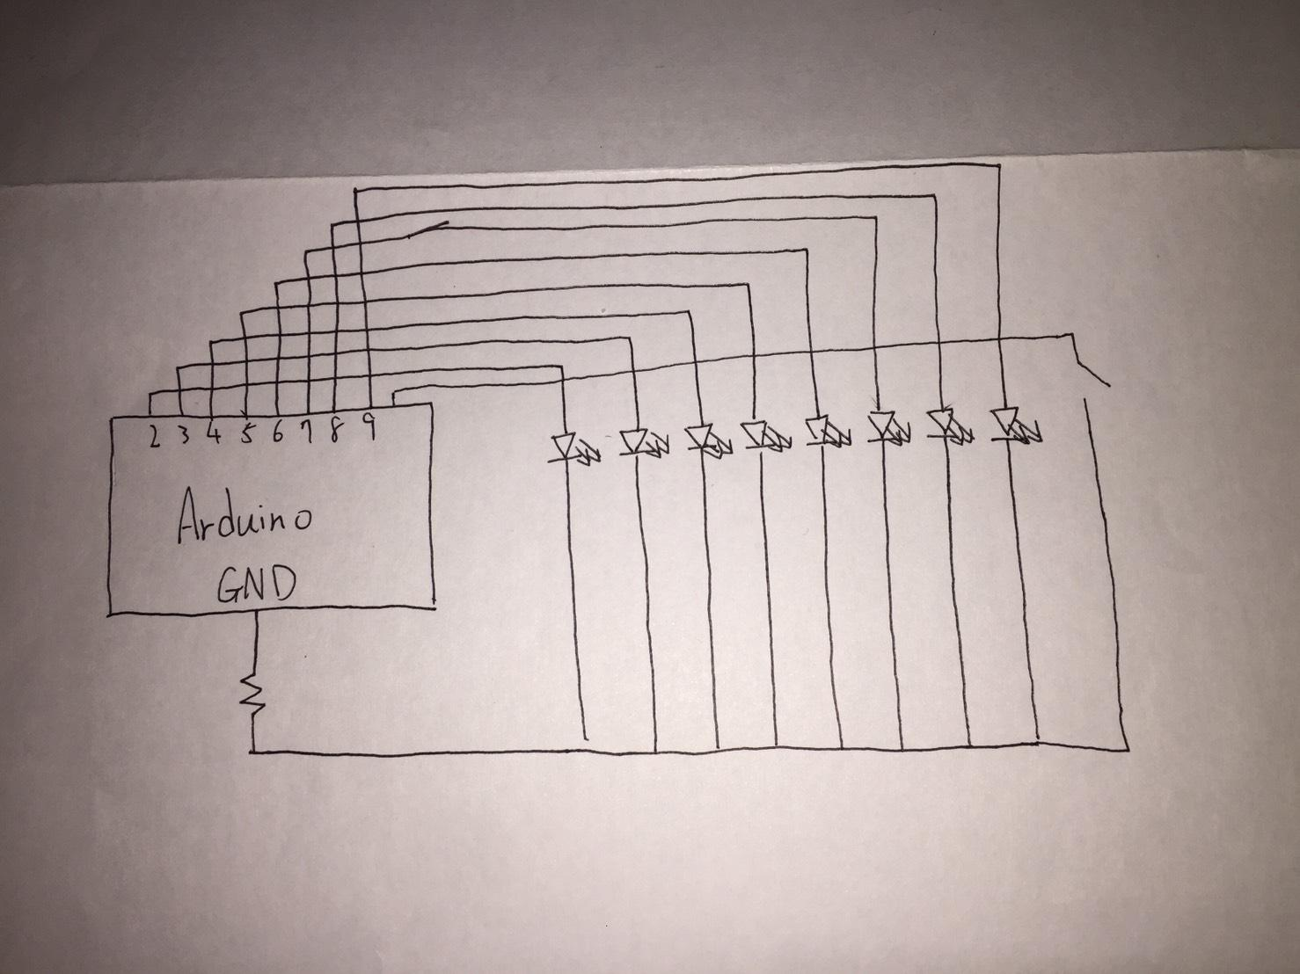

1. **心得討論**

**這次的實驗跟上次比多了一些，也比較困難，但是在同學們的互相幫助下還是成功的做出來了，希望下次的實驗也能順利跟上。**